**PRACTICAL NO: 4**

**AIM: TO SOLVE THE QUERIES USING THE CONCEPT OF JOINS AND SUB QUERIES USE FYIT_40**

Q1. FIND OUT THE ORDERS PLACED BY CUSTOMERS AND TAKEN BY SALESMAN

SELECT ORDERNO

FROM CUSTOMER C,SALESORDER SO,SALESMASTER SM

WHERE C.custno=SO.custno

AND SO.SALESMANNO=SM.SALESMANNO

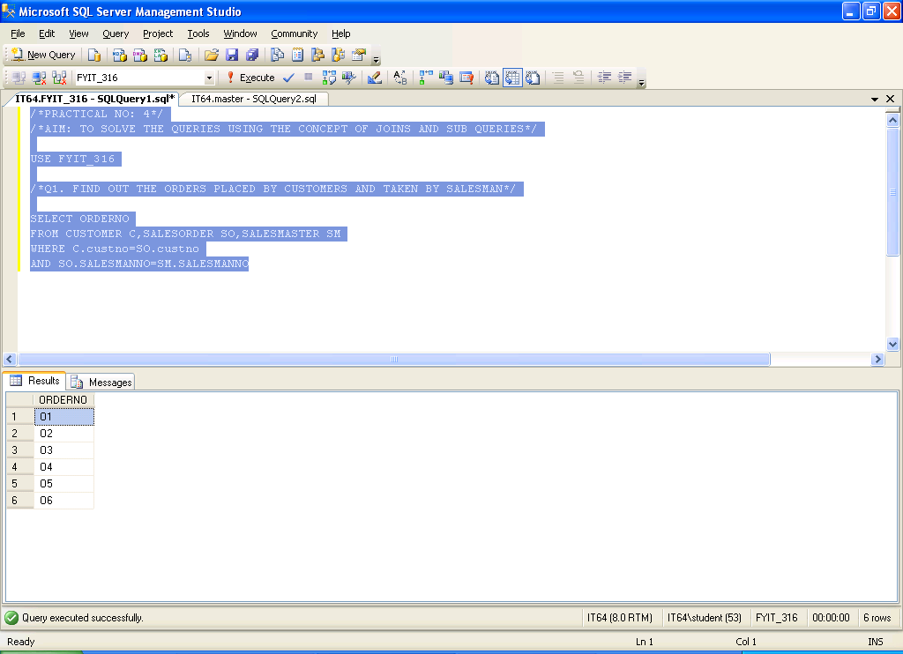

Q2. LIST THE PRODUCTNO AND DESCRIPTION OF CONSTANTLY SOLD PRODUCTS

SELECT P.PRODUCTNO,DESCRIPTION

FROM PRODUCT P, SALESORDERDETAILS SOD

WHERE SOD.PRODUCTNO=P.PRODUCTNO

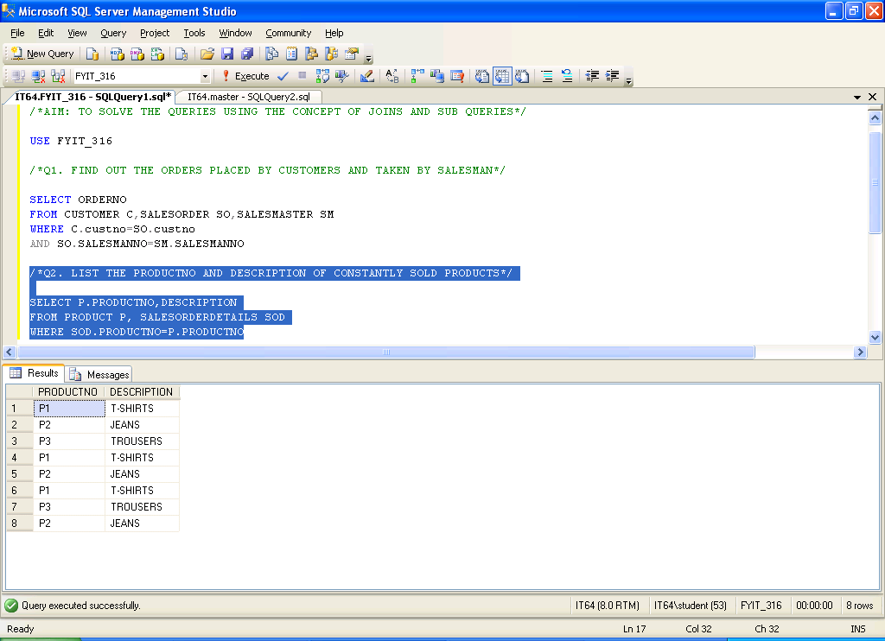

Q3. FIND OUT THE NAMES OF CUSTOMERS WHO HAVE PURCHASED TROUSERS

SELECT C.custno,cname

FROM PRODUCT P,CUSTOMER C,SALESORDER SO,SALESORDERDETAILS SOD

WHERE C.CUSTNO=SO.CUSTNO

AND SO.ORDERNO=SOD.ORDERNO

AND SOD.PRODUCTNO=P.PRODUCTNO

AND DESCRIPTION='TROUSERS'

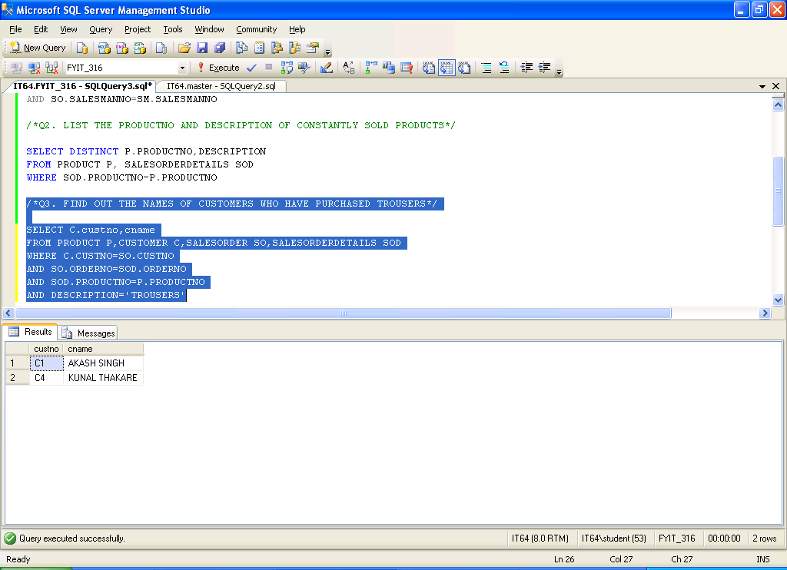

Q4. FIND OUT THE TOTAL NO OF ORDERS PLACED BY CUSTOMER FOR EACH PRODUCT

SELECT COUNT(SOD.ORDERNO) AS NO_OF_ORDERS, SOD.PRODUCTNO

FROM PRODUCT P,CUSTOMER C,SALESORDER SO,SALESORDERDETAILS SOD

WHERE C.CUSTNO=SO.CUSTNO

AND SO.ORDERNO=SOD.ORDERNO

AND SOD.PRODUCTNO=P.PRODUCTNO

GROUP BY SOD.PRODUCTNO

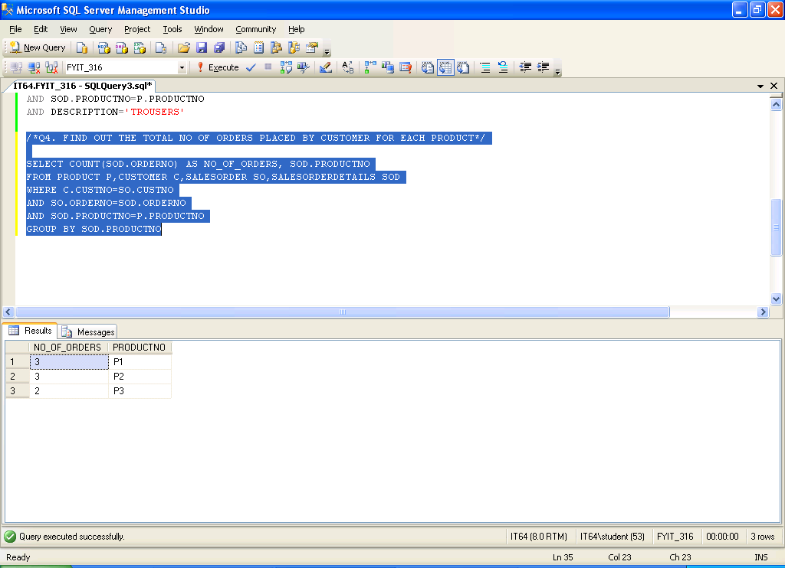

Q5. FIND OUT THE PRODUCTS WHICH HAS BEEN SOLD BY ISHAN SINGH

SELECT P.PRODUCTNO,DESCRIPTION

FROM PRODUCT P,SALESMASTER SM,SALESORDER SO,SALESORDERDETAILS SOD

WHERE P.PRODUCTNO=SOD.PRODUCTNO

AND SOD.ORDERNO=SO.ORDERNO

AND SO.SALESMANNO=SM.SALESMANNO

AND SNAME='ISHAN SINGH'

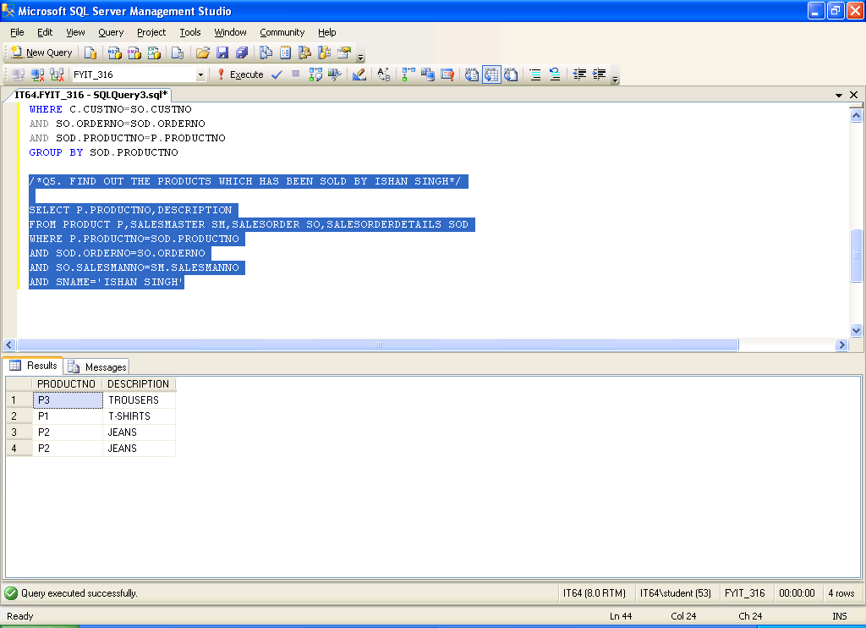

Q6. LIST THE ORDERS TAKEN BY SALESMAN(SOLVE BY SUB-QUERY)

SELECT ORDERNO

FROM SALESORDER

WHERE SALESMANNO IN (SELECT SALESMANNO FROM SALESMASTER SM)

